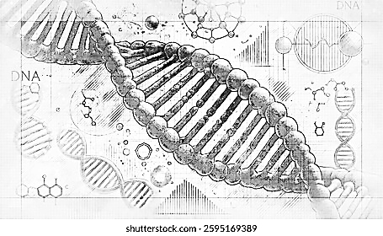
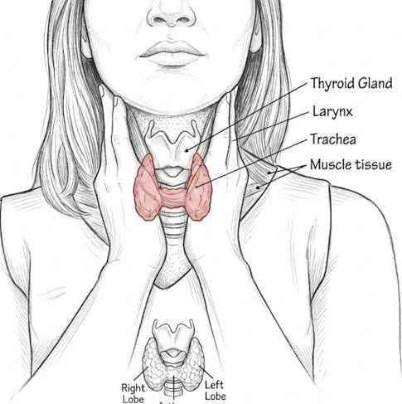

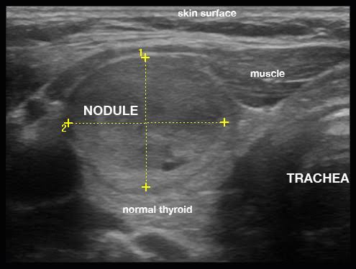

THYROID NODULE DETECTION
Using Deep Learning

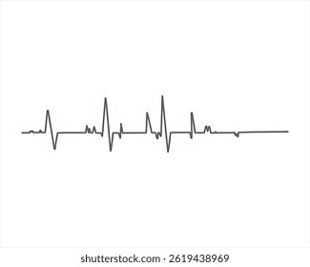

z





Deep Learning
Hybrid CNN-VGG19 architecture

Attention Mechanism
Focuses on important image regions

High Accuracy
Provides reliable classification

Medical Imaging
Analyzes thyroid ultrasound images

DOCUMENT INFORMATION
AUTHOR
Swetha. V
DATE
12-07-2026

DOCUMENT ID
TW - 008

01
PROJECT OVERVIEW

OVERVIEW
Thyroid nodules are abnormal growths that develop within the thyroid gland. While most nodules are benign, some may indicate thyroid cancer. Manual interpretation of ultrasound images can be time-consuming and subject to variation. This project applies Artificial Intelligence to assist in detecting thyroid nodules accurately and efficiently.

PROJECT OBJECTIVE
To develop a deep learning model capable of detecting and classifying thyroid nodules from ultrasound images using a Hybrid CNN-VGG19 architecture with an Attention Mechanism, improving diagnostic support and prediction accuracy.
INTENDED USERS
- Medical Researchers
- Healthcare Professionals
- Students
- AI Researchers
- Software Developers

KEY FEATURES
- Ultrasound Image Analysis
- Hybrid CNN-VGG19 Architecture
- Attention-Based Feature Extraction
- Fast and Reliable Prediction
- Clinical Decision Support

WORK FLOW
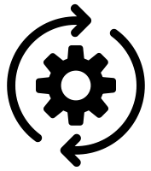



Upload
Ultrasound Image
Hybrid CNN Feature Extraction
Image
Preprocessing


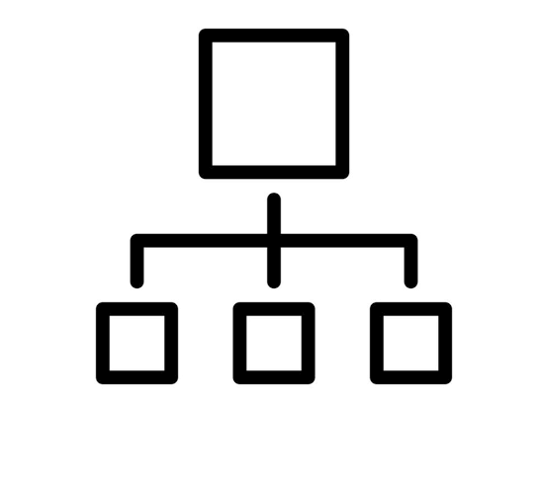


Attention
Mechanism
Prediction
Result
Classification

02
02

SYSTEM DESIGN

SYSTEM REQUIREMENTS DATASET
70% Training Set
15% Validation Set
15% Testing Set
The dataset consists of labeled thyroid ultrasound images collected from publicly available medical sources. Images are divided into training, validation, and testing datasets to evaluate the performance and reliability of the deep learning model.
Operating System | Windows 10 / Ubuntu 20.04
Programming Language | Python 3.x
RAM | 16 GB or higher
Processor | Intel Core i5 / i7
GPU (Recommended) | NVIDIA GPU with CUDA
Libraries | TensorFlow, Keras, OpenCV, NumPy, Matplotlib
Storage | 20 GB Available Space


SYSTEM ARCHITECTURE (HIGH LEVEL)
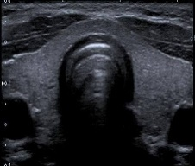

Preprocessing
Input Ultrasound Image




VGG19 Feature Extraction
Hybrid CNN

Classification & Result
Attention Mechanism
03
MODEL IMPLEMENTATION

MODEL ARCHITECTURE
02
02

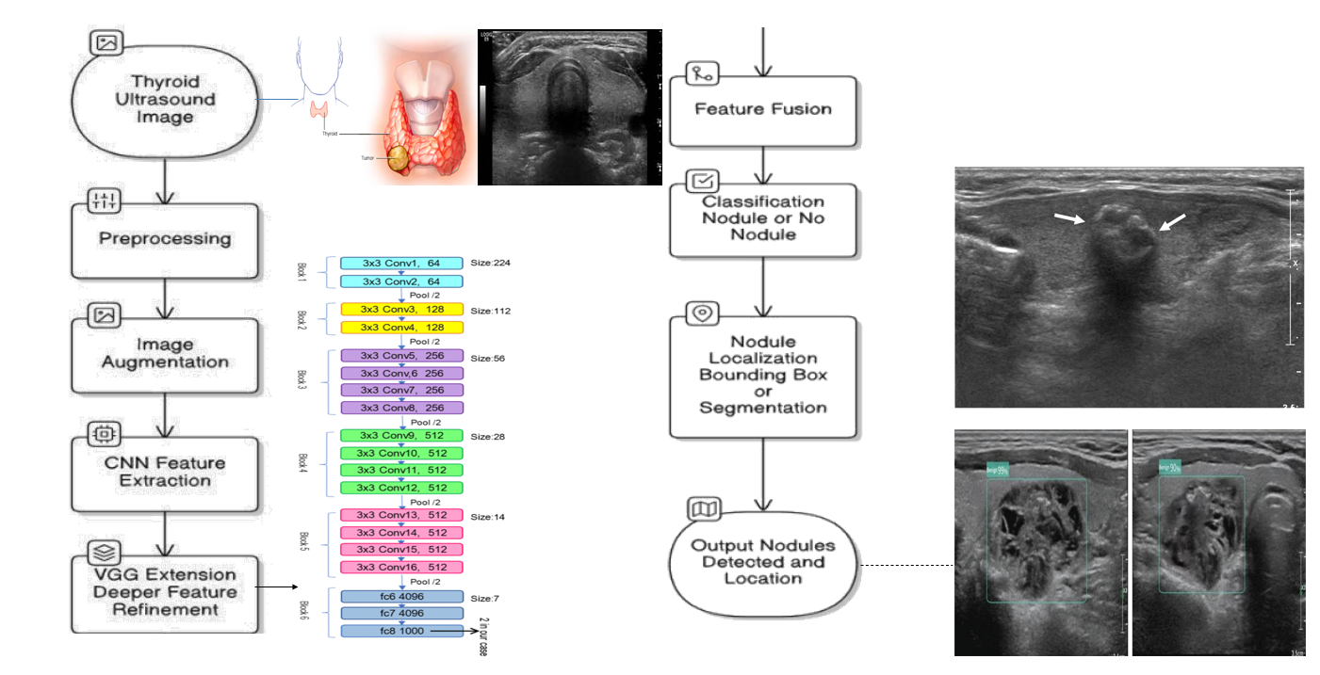

Optimizer | Adam
Loss Function | Categorical Crossentropy
Batch Size | 32
Epochs | 50
Learning Rate | 0.0001
Validation Split | 15%
Metric | Value
Accuracy | 97.21%
Precision | 96.85%
Recall | 96.92%
F1-Score | 96.88%
AUC Score | 0.987

TRAINING CONFIGURATION PERFORMANCE METRICS

RESULTS & CONCLUSION
04

RESULTS
The proposed model successfully detects and classifies thyroid nodules from ultrasound images with high accuracy. The integration of the Attention Mechanism enhances feature learning, improving prediction performance while supporting early and reliable diagnosis.
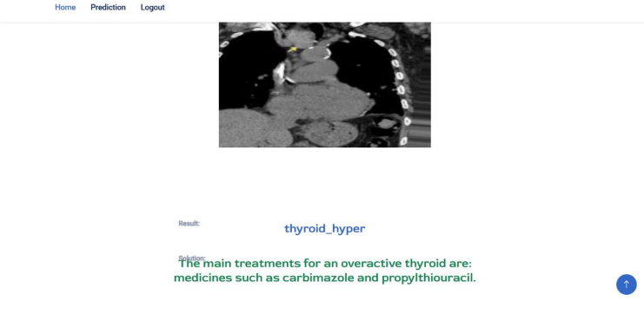

FUTURE ENHANCEMENTS
- Expand the dataset with additional medical images.
- Support multi-class thyroid disease classification.
- Deploy as a cloud-based diagnostic application.
- Integrate with hospital information systems.
- Improve real-time prediction performance.
CONCLUSION
The Thyroid Nodule Detection using Deep Learning project demonstrates how Artificial Intelligence can support medical image analysis through accurate and efficient classification. By combining deep learning with an attention mechanism, the system provides valuable assistance for healthcare professionals in diagnostic decision-making.

02
02

